Prof. Dr. Kenji Uchino, M.S., M.B.A., Ph.D.
Professor, Electrical Engineering
Director, Int’l Center for Actuators & Transducers
Materials Research Institute, The Pennsylvania State University
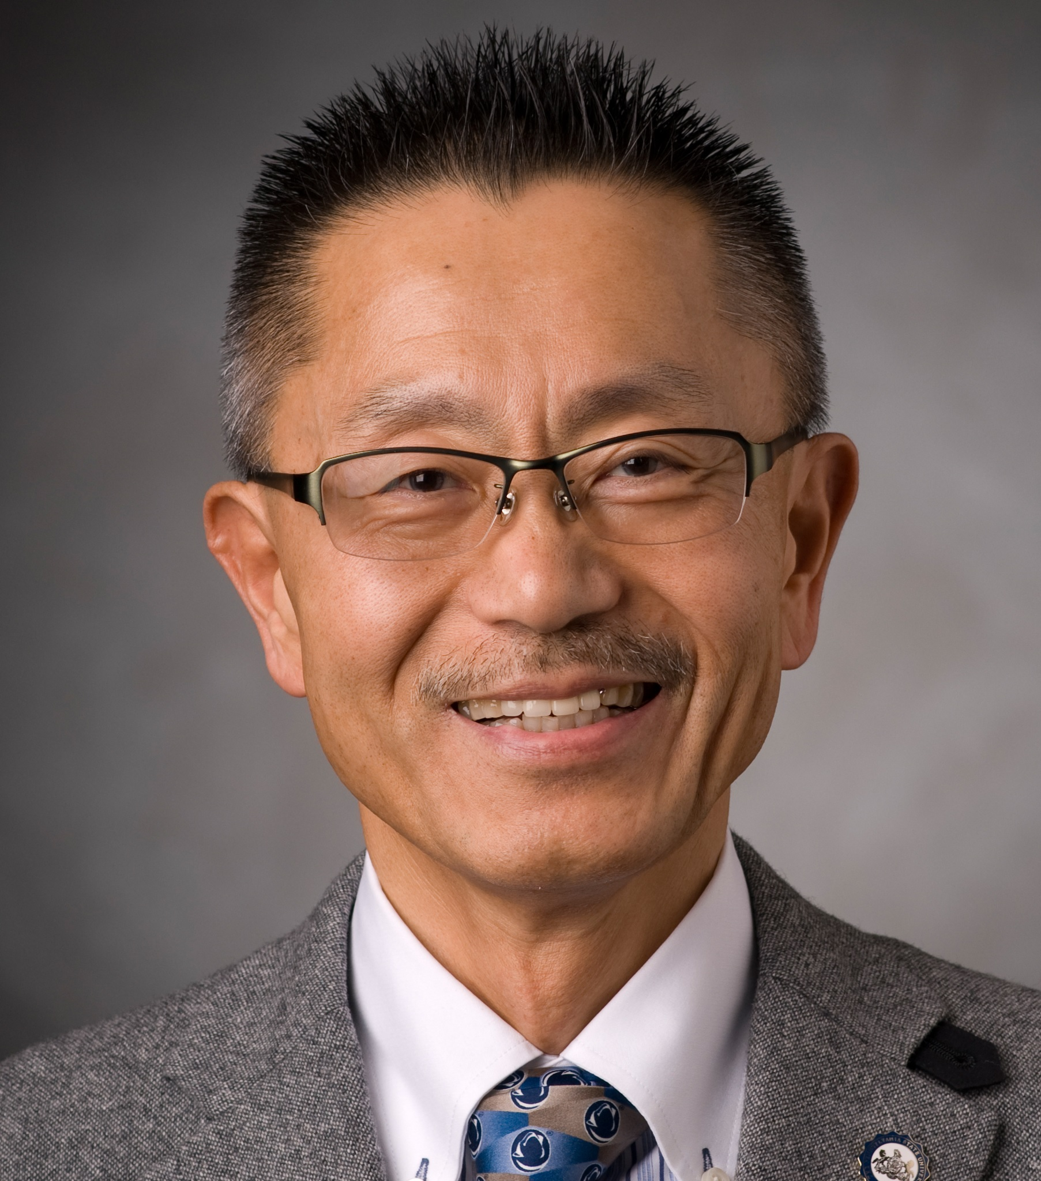
Kenji Uchino, one of the pioneers in piezoelectric actuators, is Founding Director of International Center for Actuators and Transducers and Professor of EE and MatSE at Penn State University. He was Associate Director (Global Technology Awareness) at The US Office of Naval Research – Global Tokyo Office as IPA from 2010 till 2014. He was also the Founder and Senior Vice President & CTO of Micromechatronics Inc., State College, PA. After being awarded his Ph. D. degree from Tokyo Institute of Technology, Japan, he became Research Associate/Assistant Professor (1976) in Physical Electronics Department at this university. Then, he joined Sophia University, Japan as Associate Professor in Physics Department in 1985. He was then recruited from The Penn State University in 1991. He was also involved with Space Shuttle Utilizing Committee in NASDA, Japan during 1986-88, and Vice President of NF Electronic Instruments, USA, during 1992-94. He was the Founding Chair of Smart Actuators/Sensors Committee, Japan Technology Transfer Association sponsored by Ministry of Economics, Trading and Industries, Japan from 1987 to 2014, and is a long-term Chair of International Conference on New Actuators, Messe Bremen, Germany since 1997. He was also the associate editor for Journal of Advanced Performance Materials, J. Intelligent Materials Systems and Structures and Japanese Journal of Applied Physics. Uchino served as Administrative Committee Member (Elected) of IEEE Ultrasonics, Ferroelectrics and Frequency Control (1998-2000) and as Secretary of American Ceramic Society, Electronics Division (2002-2003).
His research interest is in solid state physics, especially in ferroelectrics and piezoelectrics, including basic research on theory, materials, device designing and fabrication processes, as well as application development of solid state actuators/sensors for precision positioners, micro-robotics, ultrasonic motors, smart structures, piezoelectric transformers and energy harvesting. K. Uchino is known as the discoverer/inventor of the following famous topics: (1) lead magnesium niobate (PMN)-based electrostricive materials, (2) cofired multilayer piezoelectric actuators (MLA), (3) superior piezoelectricity in relaxor-lead titanate-based piezoelectric single crystals (PZN-PT), (4) photostrictive phenomenon, (5) shape memory ceramics, (6) magnetoelectric composite sensors, (7) transient response control scheme of piezoelectric actuators (Pulse-Drive technique), (8) micro ultrasonic motors, (9) multilayer disk piezoelectric transformers, and (10) piezoelectric loss characterization methodology. On-going research projects are also in the above areas, especially in the last three items (8), (9) and (10) most recently. He has authored 510 papers, 68 books and 31 patents in the ceramic actuator area. 37 papers/books among his publications have been cited more than 100 times, leading to his average h-index 59. Total citation number 20,100 and annual average citation number 437 are very high in College of Engineering.
He was also awarded his MBA degree from St. Francis University (2008), and authored a textbook, “Entrepreneurship for Engineers” for College of Business. He is a Fellow of American Ceramic Society since 1997, a Fellow of IEEE since 2012, and also is a recipient of 28 awards, including International Ceramic Award from Global Academy of Ceramics (2016), IEEE-UFFC Ferroelectrics Recognition Award (2013), Inventor Award from Center for Energy Harvesting Materials and Systems, Virginia Tech (2011), Premier Research Award from The Penn State Engineering Alumni Society (2011), the Japanese Society of Applied Electromagnetics and Mechanics Award on Outstanding Academic Book (2008), SPIE (Society of Photo-Optical Instrumentation Engineers), Smart Product Implementation Award (2007), R&D 100 Award (2007), ASME (American Society of Mechanical Engineers) Adaptive Structures Prize (2005), Outstanding Research Award from Penn State Engineering Society (1996), Academic Scholarship from Nissan Motors Scientific Foundation (1990), Best Movie Memorial Award at Japan Scientific Movie Festival (1989), and the Best Paper Award from Japanese Society of Oil/Air Pressure Control (1987). He is also one of the founding members of Worldwide University Network, which encourages the linking between the UK and US multiple universities since 2001.

