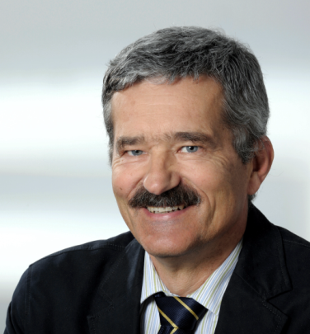Peter Greil, Prof. Dr.

Institute of Glass and Ceramics

University of Erlangen-Nuernberg

D-91058 Erlangen, Germany

Peter Greil is a professor of Materials Science and chair of Glass and Ceramics at the Department of Materials Science of the University of Erlangen-Nuernberg, Germany. He received his Dipl.Ing. in mineralogy in 1980 and a PhD in metallurgy in 1982 from University of Stuttgart. Before joining Erlangen University in 1993 he worked for the Max-Planck-Institute for Metals Research as a group leader of engineering ceramics group and held a position as associate professor for advanced ceramics at the Technical University of Hamburg-Harburg. In 2002 and 2005 he was invited as a guest professor at the Universities of Leoben, Austria, and Rennes, France and from 2010-2015 he was a visiting professor at the Nagoya Institute of Technology, Japan. Currently he serves as the Dean of Faculty of Engineering.

Greil´s research on advanced processing of ceramics centered on non-oxide ceramics, polymer and metal derived ceramic composites, and biomorphous cellular ceramics. He has published more than 320 papers and 42 patents. He received several awards including the Otto Hahn Medal from Max-Planck Society (1983), Purdy Award from the American Ceramic Society (1996), Leibniz Award from the German Science Foundation (2000), Seeger Award from German Ceramics Society (2005) and was elected as Academician of the World Academy of Ceramics (1990), Fellow of the American Ceramic Society (2002) and of the European Ceramic Society (2015).

Greil acts as co-coordinator of the DFG-priority program for Nanoscale Materials, Coordinator of the Bavarian Research Network on Advanced Ceramic Technologies and the VW-Junior Research Group on Biomimetic Materials Synthesis. As the chairman of the committee on Physical and Chemical Aspects of Ceramics of the German Ceramic Society, and head of joint committee on Polymer Derived Ceramics of German Ceramic and German Materials Societies he organizes various interdisciplinary networks related to advanced ceramic materials and processes.